Фролов Кирилл УБ-11

4 практика 3 задание 9 вариант

import java.time.LocalDate;  
import java.time.format.DateTimeFormatter;  
import java.time.DayOfWeek;  
  
public class untuitled {  
 public static void main(String[] args) {  
 LocalDate today = LocalDate.*now*();  
 int year = today.getYear();  
  
 LocalDate september1 = LocalDate.*of*(year, 9, 1);  
 DateTimeFormatter formatter = DateTimeFormatter.*ofPattern*("d MMMM yyyy EEEE");  
  
 DayOfWeek dayOfWeek = september1.getDayOfWeek();  
 String dayOfWeekName = dayOfWeek.getDisplayName(TextStyle.FULL, Locale.getDefault());  
  
 System.*out*.println("Дата 1 сентября " + year + " года: " + september1.format(formatter) + " " + dayOfWeekName);  
 }  
}

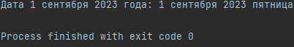

9 вариант